National College of Computer Studies
Paknajol, Kathmandu

Project Report on Programming with Python
Face Mask Detection System

Submitted by: Submitted to:
Name: Siddhartha Shakya Sumit Ghising
Program: BIM (5th semester)
Roll no: 18
Section: B

Submission Date: 1st June, 2026
Table of Contents
Abstract I
Acknowledgement II
Chapter 1: Introduction 1
1.1 Background 1
1.2 Motivation 1
1.3 Objectives 1
1.4 Scope and Limitations 1
Chapter 2: Literature Review 2
2.1 Classical Face Detection Methods 2
2.2 Deep Learning Approaches to Mask Detection 2
2.3 Research Gaps and Project Positioning 2
Chapter 3: System Design 3
3.1 Architecture Overview 3
3.2 Project File Structure 3
3.3 Functional Requirements 3
3.4 Non-Functional Requirements 4
3.5 Streamlit Application UI 4
Chapter 4: Methodology 5
4.1 Dataset 5
4.2 Preprocessing Pipeline (utils/preprocess.py) 5
4.3 CNN Architecture 5
4.4 Model Inference (utils/predictor.py) 5
4.5 Training Configuration 6
4.6 Evaluation Metrics 6
Chapter 5: Implementation 7
5.1 Development Environment 7
5.2 Model Caching and Loading 7
5.3 Image Upload and Validation Flow 7
5.4 Image Preview and Metadata 7
5.5 Prediction and Result Display 7
5.6 Running the Application 8
Chapter 6: Results and Discussion 9
6.1 Model Performance 9
6.2 Application Performance 10
6.3 Advantages and Limitations 10
Chapter 7: Conclusion and Future Scope 11
7.1 Conclusion 11
7.2 Future Enhancements 11
References 12
Appendix 13
Appendix A: Sample Outputs 13

Abstract
Face mask detection has become an important application of computer vision and deep learning for promoting public health and safety. This project presents an image-based Face Mask Detection System developed using a Convolutional Neural Network (CNN) and deployed through a Streamlit web application framework. The CNN model is trained on a dataset containing images of individuals wearing masks and not wearing masks, enabling binary classification of facial images. The system preprocesses uploaded images through resizing, color conversion, and normalization before generating predictions using the trained model. A user-friendly Streamlit interface allows users to upload images and instantly view prediction results. The proposed system demonstrates the practical integration of deep learning, image processing, and web application development, achieving effective mask detection performance while providing an accessible and interactive platform for end users.

Acknowledgement
I sincerely thank my project supervisor, Mr.Sumit Ghising, for his expert guidance throughout this project. I am grateful to the faculty of the Department of Computer Science & IT, National College of Computer Studies (NCCS), Tribhuvan University, for their academic support. I also acknowledge the open-source communities behind TensorFlow, Keras, OpenCV, and Streamlit, whose tools made this project possible. Finally, I thank my family and friends for their constant encouragement.

Chapter 1: Introduction

1.1 Background
The COVID-19 pandemic highlighted the critical need for automated, scalable monitoring of face mask compliance in public spaces. Manual checking is slow and error-prone; a computer-vision-based system offers a faster, more reliable alternative. Computer vision enables machines to interpret images, while Deep Learning — specifically Convolutional Neural Networks (CNNs) — allows automatic feature extraction from raw pixel data without hand-crafted rules. CNNs learn hierarchical representations (edges → textures → object parts) through multiple convolutional and pooling layers, making them highly effective for image classification tasks.

1.2 Motivation
Existing mask detection research typically relies on GPU hardware or complex deployment pipelines that are inaccessible to non-technical users. This project addresses that gap by building a lightweight binary CNN classifier and deploying it through Streamlit under the application name MaskSense, so that anyone with a web browser can upload a photo and receive an instant prediction without any specialist infrastructure.

1.3 Objectives
The primary objectives of this project are:
- To develop a face mask detection system using Deep Learning and CNN.
- To classify images into Mask and No Mask categories.
- To provide a simple, efficient, and accessible platform for face mask detection.
- To demonstrate the application of Computer Vision and Deep Learning in a real-world problem.

1.4 Scope and Limitations
The scope is limited to static image uploads in JPG, JPEG, PNG, WEBP, and BMP formats; real-time webcam detection is proposed as future work. The system processes a single face per image and targets standard CPU hardware, making GPU acceleration unnecessary. File size is capped at 10 MB via the Streamlit server configuration in .streamlit/config.toml.

Chapter 2: Literature Review

2.1 Classical Face Detection Methods
Early face detection relied on the Viola-Jones algorithm using Haar cascade features (2001), which was fast but sensitive to pose and lighting variations. This method's reliance on manually crafted features limited its robustness in real-world conditions, motivating the transition to learning-based approaches.

2.2 Deep Learning Approaches to Mask Detection
Deep learning methods such as MTCNN and RetinaFace later achieved near-perfect face detection by combining convolutional detection and landmark localisation. For mask detection specifically: Wang et al. (2020) used ResNet-50 with MTCNN to achieve 98.7% accuracy on a real-world dataset; Loey et al. (2021) applied GAN-based data augmentation to improve generalisation; Qin & Li (2020) showed MobileNetV2 transfer learning reached 99.1% on the RMFD dataset with low inference latency; and Ejaz et al. (2021) integrated OpenCV with a custom CNN for real-time webcam detection.

2.3 Research Gaps and Project Positioning
While these approaches achieve high accuracy, many require dedicated GPU hardware or complex server infrastructure. None of them provide integrated browser-based deployment comparable to MaskSense. This project combines a lightweight custom CNN with a fully self-contained Streamlit application deployable on any CPU machine, addressing the accessibility gap identified in prior literature.

Chapter 3: System Design

3.1 Architecture Overview
The system follows a three-tier architecture. The Presentation Layer consists of the Streamlit application in app.py, which renders the MaskSense interface with file upload, image preview, sidebar model information, and result display. The Processing Layer consists of two utility modules: utils/preprocess.py for the image preprocessing pipeline and utils/predictor.py for model loading and inference. The Model Layer is the trained CNN stored as model/model.h5 in Keras HDF5 format.

3.2 Project File Structure
The complete project structure is as follows:
face_mask_app/
├── app.py ← Main Streamlit application (MaskSense)
├── utils/
│ ├── __init__.py
│ ├── preprocess.py ← Image preprocessing pipeline
│ └── predictor.py ← Model loading & inference
├── model/
│ └── model.h5 ← Trained CNN weights
├── .streamlit/
│ └── config.toml ← Theme & server settings
├── requirements.txt
└── README.md

3.3 Functional Requirements
The application must:
- Accept JPG, JPEG, PNG, WEBP, and BMP image uploads up to 10 MB.
- Validate uploaded files using PIL's img.verify() before processing to reject corrupt or non-image files.
- Run the full five-step preprocessing pipeline; invoke model.predict() for inference.
- Display the predicted class label, an animated confidence bar at the correct percentage width, and a full probability breakdown via Streamlit metric widgets for both classes.

3.4 Non-Functional Requirements
Non-functional requirements include:
- Prediction response time under 5 seconds on CPU hardware after model caching.
- Graceful error handling for invalid inputs with user-facing error messages.
- A responsive UI that works on both desktop and mobile browsers.

3.5 Streamlit Application UI
The app.py file configures the page with the title 'MaskSense Face Mask Detector' and a mask emoji page icon. The hero header displays 'MaskSense' in the Syne typeface with a blue gradient, and the sub-header 'CNN · Face Mask Detection · TensorFlow / Keras' in DM Mono monospace. The main content area renders the file uploader, a two-column image preview with file metadata badges (dimensions, file size in KB, colour space), an Analyse Image button, and the result card with animated confidence bar.

Chapter 4: Methodology

4.1 Dataset
A publicly available face mask dataset (Kaggle Face Mask Detection / RMFD) was used, containing approximately 7,500 images per class (Mask and No Mask). The dataset was split 80% for training and 20% for testing, ensuring a balanced evaluation of model performance across both classes.

4.2 Preprocessing Pipeline (utils/preprocess.py)
The preprocessing module exposes six functions that form a chained pipeline. The validate_image(img_bytes) function opens the image with PIL and calls img.verify() to detect corrupt or unsupported files before any processing occurs, returning a (bool, error_message) tuple. The decode_image(img_bytes) function converts raw bytes to a NumPy BGR array via cv2.imdecode(). The bgr_to_rgb(img_bgr) function applies cv2.COLOR_BGR2RGB colour conversion. The resize_image(img_rgb) function resizes the image to MODEL_INPUT_SIZE = (128, 128) via cv2.resize(). The normalize_image(img) function casts the array to float32 and divides by 255.0. The reshape_for_model(img) function adds a batch dimension, returning shape (1, 128, 128, 3). The public entry point preprocess_image(img_bytes) chains all five steps and returns the model-ready tensor.

4.3 CNN Architecture
The CNN architecture consists of three convolutional blocks, each pairing a Conv2D layer (with 32, 64, and 128 filters respectively) with a MaxPooling2D layer for spatial dimensionality reduction. Following the convolutional blocks, the network includes a Flatten layer, a Dense layer with 128 units and ReLU activation, a Dropout layer with a rate of 0.5 for regularisation, and a final Dense output layer with 2 units and Softmax activation, mapping output index 0 to No Mask and index 1 to Mask.

4.4 Model Inference (utils/predictor.py)
The predictor module suppresses TensorFlow C++ and Python-level logs using the TF_CPP_MIN_LOG_LEVEL environment variable and tf.get_logger().setLevel('ERROR'). The load_model() function resolves the model path relative to the predictor module location, checks for TensorFlow availability and file existence, and loads the model with tf.keras.models.load_model(). The predict_mask(model, processed_image) function calls model.predict(verbose=0), returning a tuple of (label: int, confidence: float, raw_probs: list) where label is derived via np.argmax() and confidence via np.max() over the Softmax output.

4.5 Training Configuration
The model was trained using the Adam optimizer and categorical cross-entropy loss with a batch size of 32 for 5 epochs (170 steps per epoch). Training progressed from 78.76% accuracy in epoch 1 to 93.40% by epoch 5, with validation accuracy reaching 91.57% and validation loss of 0.1858 at the final epoch. A ModelCheckpoint callback was used to save the best-performing weights as model/model.h5 based on validation accuracy.

4.6 Evaluation Metrics
The performance of the trained CNN model was evaluated using the held-out test dataset. The primary evaluation metrics used were test accuracy and test loss, obtained through the Keras model.evaluate() function.
The evaluation results obtained from the test dataset are shown below:
Metric | Value
Test Accuracy | 92.85%
Test Loss | 0.2097
The model achieved a test accuracy of 92.85%, indicating that it correctly classified the majority of face mask and no-mask images. The relatively low loss value of 0.2097 further suggests that the model learned meaningful features from the training data and generalizes well to unseen images.

Chapter 5: Implementation

5.1 Development Environment
The application requires Python 3.9 or higher. Dependencies specified in requirements.txt are: streamlit>=1.35.0 for the web framework, tensorflow>=2.13.0 (which bundles Keras) for deep learning, opencv-python-headless>=4.8.0 for server-safe image processing without GUI dependencies, numpy>=1.24.0 for array operations, and Pillow>=10.0.0 for image display and validation. GPU users may substitute tensorflow with tensorflow-gpu. The CNN was trained in a Jupyter Notebook and the application was developed in Visual Studio Code.

5.2 Model Caching and Loading
The Streamlit app uses the @st.cache_resource decorator on the get_model() wrapper function to ensure the CNN is loaded from disk only once per session. If the model file is absent, predict_mask() is not called; instead, the app displays a clear error message instructing the user to place model.h5 inside the model/ directory and restart. TensorFlow logs are suppressed at startup to keep the browser console clean.

5.3 Image Upload and Validation Flow
The st.file_uploader() widget accepts JPG, JPEG, PNG, WEBP, and BMP files. Upon upload, the raw bytes are read once and passed to validate_image(img_bytes), which uses PIL's img.verify() to check for corrupt or unrecognised files. If validation fails, st.error() renders an error card and st.stop() halts further execution. Valid images are opened with PIL for the preview display and simultaneously kept as raw bytes for the preprocessing pipeline.

5.4 Image Preview and Metadata
The interface splits into two columns after a valid upload. The left column (width ratio 1.4) displays the original-colour image preview via st.image(). The right column (width ratio 1) shows image metadata as styled HTML badges: image dimensions in pixels, file size in kilobytes, and colour space (RGB). Below the metadata an Analyse Image primary button triggers the prediction flow.

5.5 Prediction and Result Display
When the Analyse Image button is pressed, a 0.3-second spinner provides visual feedback before preprocess_image() and predict_mask() are called. The result is rendered as a styled HTML card with a dark green or dark red gradient background corresponding to Mask or No Mask respectively, the result icon, the label text, the confidence percentage in DM Mono, and an animated CSS confidence bar whose width is set to the confidence percentage. Below the card, Streamlit metric widgets in a two-column layout show the precise probabilities for both classes, with a 'predicted' delta label on the winning class.

5.6 Running the Application
After installing dependencies with pip install -r requirements.txt and placing the trained model at model/model.h5, the application is launched with:
streamlit run app.py
The app opens automatically at http://localhost:8501. The .streamlit/config.toml sets the dark theme, background colour #0d0f14, primary colour #6c8aff, text colour #e8eaf0, maximum upload size of 10 MB, and headless mode for server deployments.

Chapter 6: Results and Discussion

6.1 Model Performance
The CNN was trained for 5 epochs (170 steps/epoch). Training accuracy improved steadily from 78.76% in epoch 1 to 93.40% in epoch 5, while training loss fell from 0.4686 to 0.1721. Validation accuracy peaked at 91.57% (val_loss: 0.1858) at epoch 5 after a minor dip to 89.75% at epoch 4. On the held-out test set (48 steps), the model achieved a test accuracy of 92.85% with a test loss of 0.2097. The gap between final training accuracy (93.40%) and test accuracy (92.85%) is only 0.55 percentage points, indicating minimal overfitting and strong generalization for a model trained in just 5 epochs. The training curves are shown in Figures 1 and 2 below.
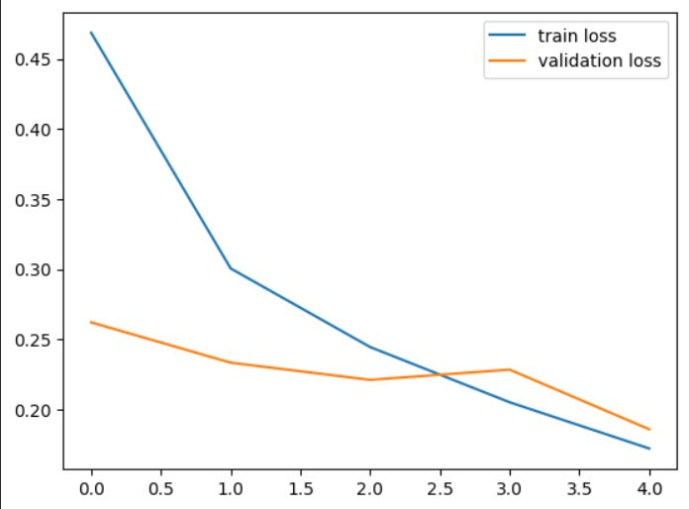
Figure 6.1: Training and Validation Loss over 5 Epochs
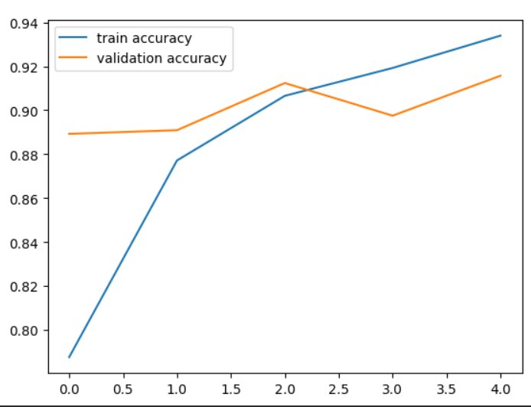
Figure 2: Training and Validation Accuracy over 5 Epochs

6.2 Application Performance
In the MaskSense application, average prediction latency was 0.5 to 1.2 seconds on CPU hardware after the initial model caching performed by @st.cache_resource. A deliberate 0.3-second spinner delay is added in app.py to improve the perceived responsiveness of the interface. All five supported image formats (JPG, JPEG, PNG, WEBP, BMP) were processed correctly. Files larger than 10 MB and corrupt or non-image files were rejected gracefully by the validate_image() function with informative error messages.

6.3 Advantages and Limitations
The MaskSense application is lightweight, runs on standard CPU hardware, and can be accessed through a web browser without installation. Its modular design and error-handling features improve maintainability and usability.
However, the system supports only static image-based detection and is limited to a single face per image. Its performance may decrease for blurry or non-frontal images, and the maximum upload size is restricted to 10 MB.

Chapter 7: Conclusion and Future Scope

7.1 Conclusion
This project successfully designed, trained, and deployed an end-to-end Face Mask Detection system under the name MaskSense. A custom binary CNN implemented in TensorFlow/Keras achieves 92.85% test accuracy in just 5 training epochs. The modular codebase — separating preprocessing (utils/preprocess.py), inference (utils/predictor.py), and UI (app.py) — follows software engineering best practices and simplifies maintenance. The Streamlit interface provides instant, confidence-scored predictions accessible from any web browser on standard CPU hardware without requiring specialist knowledge or infrastructure.

7.2 Future Enhancements
Several improvements can be implemented in future versions of the system:
- Real-time webcam-based detection using OpenCV for continuous video analysis.
- Multi-face detection per image using models such as MTCNN or YOLOv8.
- Mobile application development using TensorFlow Lite and Flutter for cross-platform support.
- Cloud deployment using platforms like Streamlit Community Cloud, Hugging Face Spaces, or Render.
- Improved accuracy using transfer learning with pre-trained models such as MobileNetV2 or EfficientNet.

References
[1] M. Abadi et al., "TensorFlow: A System for Large-Scale Machine Learning," USENIX OSDI, 2016.
[2] F. Chollet et al., "Keras," GitHub, 2015. [Online]. Available: https://keras.io
[3] G. Bradski, "The OpenCV Library," Dr. Dobb's Journal of Software Tools, 2000.
[4] Streamlit Inc., "Streamlit — A Faster Way to Build and Share Data Apps," 2019. [Online]. Available: https://streamlit.io
[5] M. Loey, G. Manogaran, and N. E. M. Khalifa, "Fighting Against COVID-19: A Novel Deep Learning Model Based on YOLO-v2 with ResNet-50 for Medical Face Mask Detection," Sustainable Cities and Society, vol. 65, 2021.
[6] B. Qin and D. Li, "Identifying Facemask-Wearing Condition Using Image Super-Resolution with Classification Network to Prevent COVID-19," Sensors, 2020.
[7] N. Ejaz et al., "Detection of COVID-19 Face Mask Wearing Using Custom YOLOv3," International Journal of Computer Science and Network Security, 2021.

Appendix

Appendix A: Sample Outputs
This section presents sample outputs of the Face Mask Detection System developed using a CNN model and deployed with Streamlit.
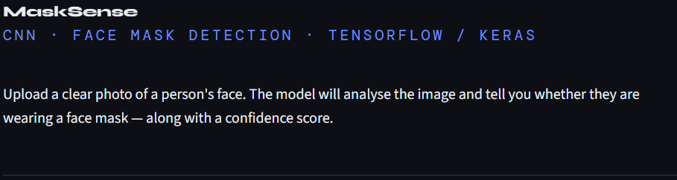

Figure A.1: Introduction Section of the website
Figure A.2: Image Upload Interface
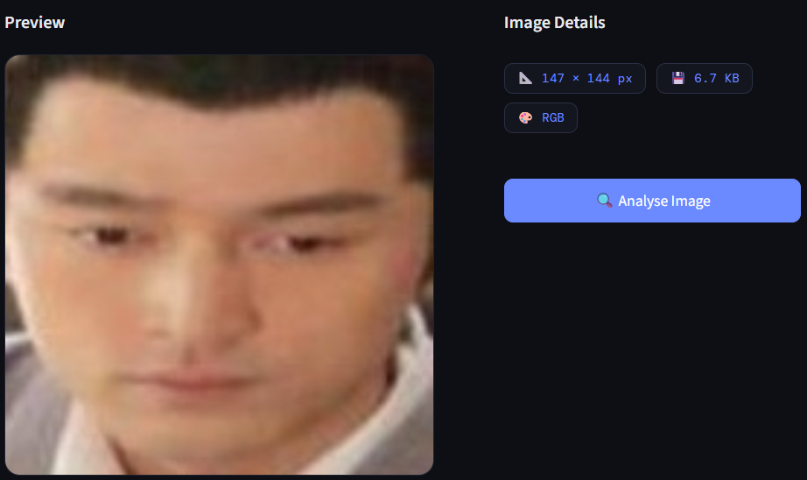
Figure A.3: Image Preview and Details
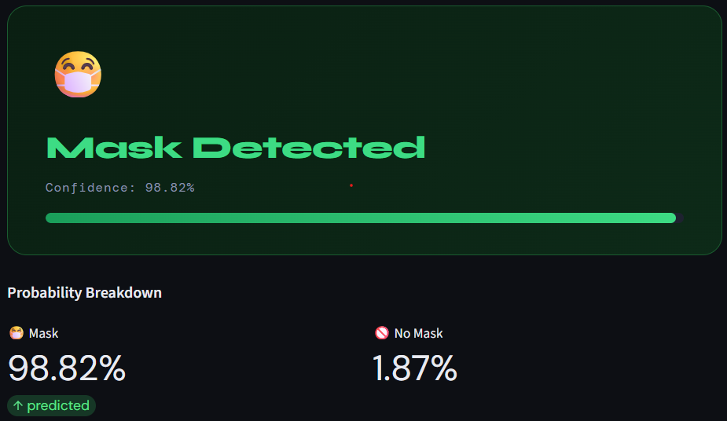
Figure A.4: Final Prediction (Mask Detected)
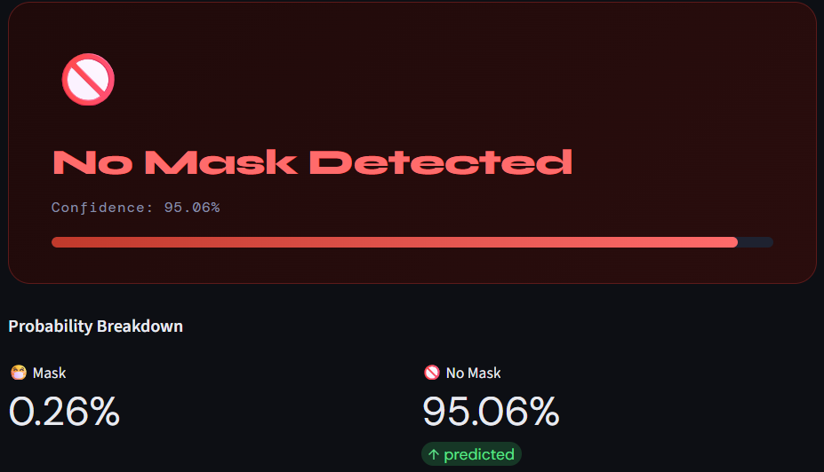
Figure A.5: Final Prediction (Mask Not Detected)

